Operation Juniper Spear Phase 2
Southern Somalia Desert
Mech. Inf. Task Unit and Supporting Elements

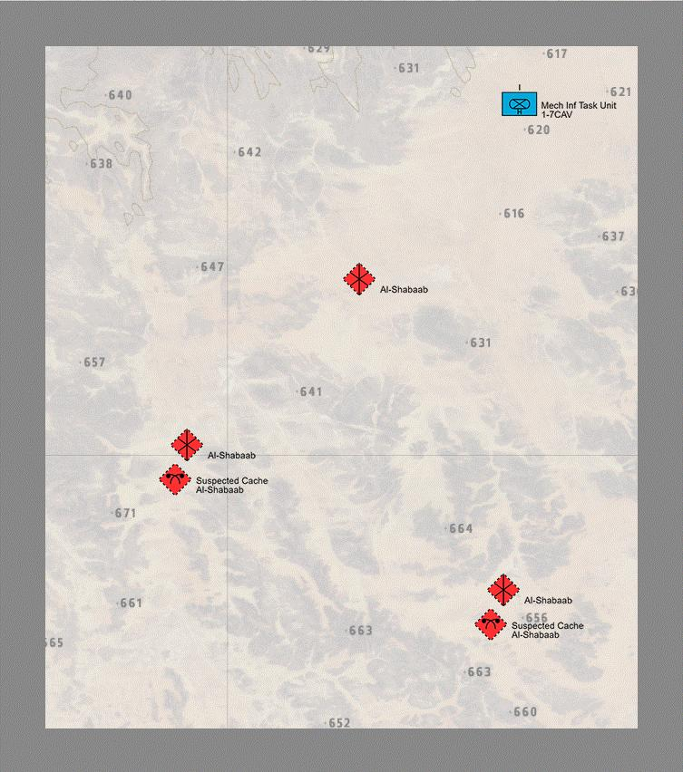 | Situation: Al Shabaad forces have withdrawn from Mogadishu and, after splitting into two seperate elements, are moving south towards Kenya. It is unknown which of the two elements have taken the WMDs, or Ahmad Umar himself. 1-7 CAV, 1ABCT has been re-tasked to pursue the WMDs and Umar. While the Air Assault Task Unit will be pursuing the elements in the jungles of southern Somalia, the Mechanized Infantry Task Unit will be pursuing the elements in the deserts of southern Somalia.
 | Mission Maker Notes: The Mechanized Infantry Task Unit will find the location of Umar during mission 16. No WMDs will be found.
Mission Overview:

10 - Aviation elements will conduct reconnaissance mission to confirm location of suspected OPFOR sites.

11 - Mech. Inf element will move south to further recon in force, and to seize OPFOR encampments in the center of the AO as a part of the initial conduct of this phase.

15 - Support element will provide follow-on support by breaching obstacles found blocking Mech. Inf. from moving further south towards suspected caches.

16 - Mech. Inf element will attack suspected supply caches, seize them, and capture HVTs who provide location of Umar.

